**Data Analysis Project 2**

**Fifa World CupData**

**O/P**

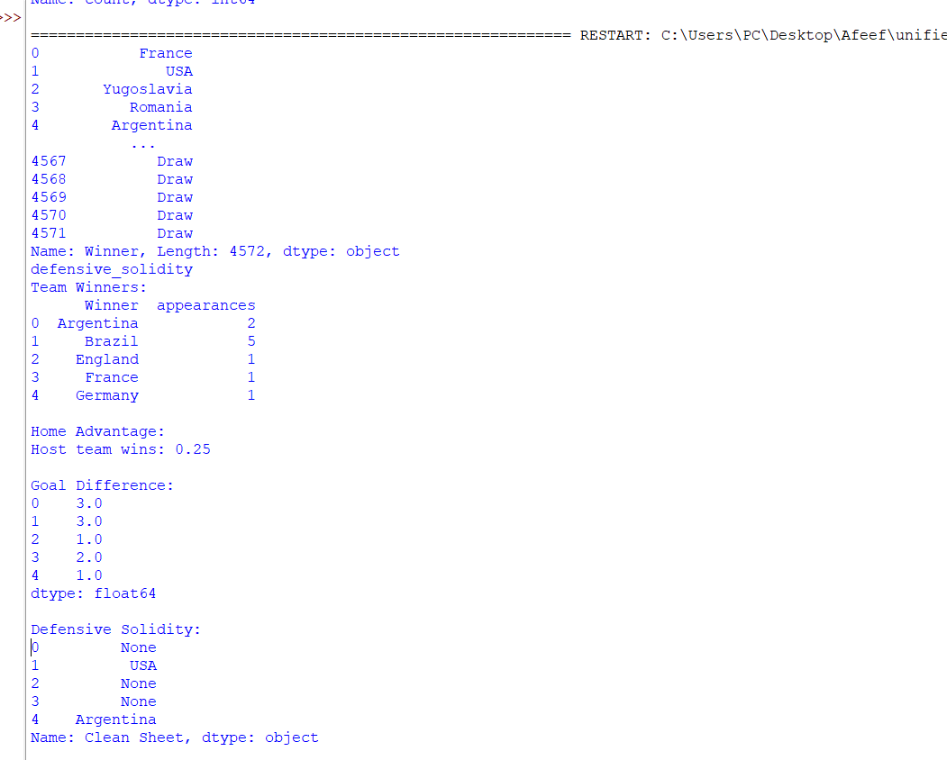

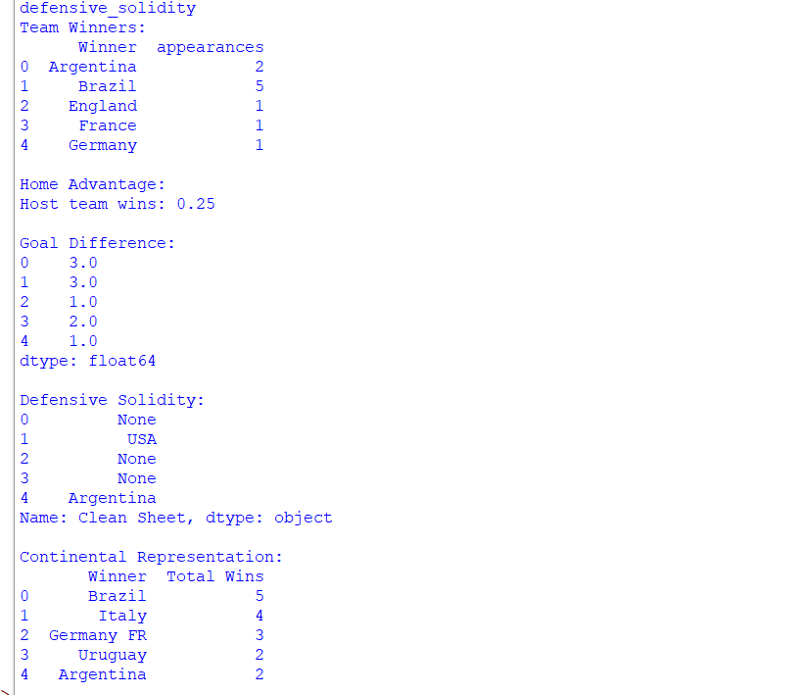

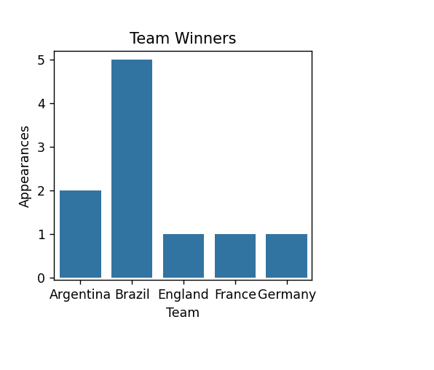

**Tableau**

https://public.tableau.com/views/FootballWorldCup_17211838471000/TeamsGoals?:language=en-US&publish=yes&:sid=&:redirect=auth&:display_count=n&:origin=viz_share_link

